Copper Classic Cluster Dog Show

Prescott Valley Event Center

September 21-24, 2018

Welcome to the 2018 Nationals Weekend  I hope that this weekend is full of old friends, new friends, fun and smiles for each of you.  Along with lots of dogue kisses and drool.  This year has had some struggles, What year doesn't. But the show committee is proud to have you enjoy this weekend. I am especially thankful to those members and non-members that stepped up to help no matter what was asked of them  I also want to give a huge thank you to those people that are never acknowledged. These people are the partners, spouses, family and friends of each of us that are out there competing and training with our dogs. So many of them are only a name that others have never seen at a show. These wonderful people give their support in so many ways and rarely get a thank you. Please reach out and thank them, give them a hug or shake their hand when you see them. Many times they are the backbone of what we "dog people" do.  Val.  Thank you for being here and remember  If you see me cussing - RUN  If you see me napping - LEAVE ME ALONE  if you see me Laughing - PLEASE JOIN ME |  |  | The Show Committee would like to thank Group Management Services (GMS) for their generous donation of the printing of these show catalogs. Please visit their website at www.groupmgmt.com.
 |  |  | 5

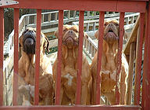  The National Show Committee would like to thank everyone who has shown their support of this show! Whether monetarily, donation of time and effort, attendance or all the above, your generosity and support has made this show possible and we THANK YOU!!! |  |  | DDBSA Officers  President – Kathi Cannon  Vice President – Michal Whitney  Recording Secretary – Joy Chicatelli  Corresponding Secretary – Angie Reed  Treasurer – Open (acting Treasurer – Kathi Cannon)  Board of Directors  Val Barr  Dietrich Brown  Lauren Parker  Viola Shannon  Sonja Fairfax-Tompkins  Club AKC Liason  Victor Smith  Show Committee  Chair – Val Barr  Kathi Cannon  Cheryl Ozbirn  Sonja Fairfax-Tompkins  DDBSA BOD  Judge Selection  Kathi Cannon  Cheryl Ozbirn  Top 20  Val Barr Kathi Cannon  Cheryl Ozbirn Sonja Fairfax-Tompkins
4 |  |  | 1

Events Schedule  Thursday – Judges Ed 4 pm (ringside mentoring available all days)  Friday – Supported Entry, Handling Seminar, Top 20 at 7 pm at Event Center – Sponsored by Grant & Michal Whitney, Parade of Rescues  Saturday – Specialty Day, Club Meeting, Annual Awards  Sunday – Sweeps, Supported Entry, Fun and Games at Club Tent (costume contest, longest drool, best kisser, dogue tricks), No host dinner at Restaurant  Monday – Supported Entry  Please check in at the Club Tent to get up to date time and locations of the Membership meeting and the Sunday dinner. |  |  | 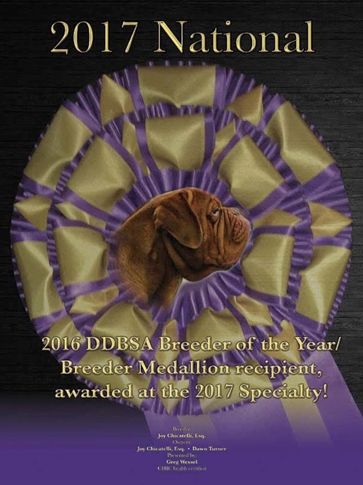  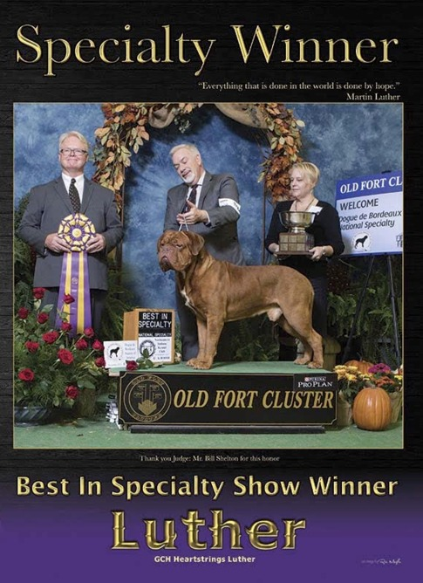

2 |  |  | 3

